VPrivCal Expert Review
  - Interface-aligned screening workbook for VPrivCal-Q10 and VPrivCal-Probe
Short workshop version for professional researchers
Decision / research question
Are the three-option category triggers, five-point cross-cutting agreement questions, expert-verified exposure labels, Probe interface, and held-out acceptance evaluation sufficiently clear, low-burden, and testable?

Method at a glance
Element | Current design
VPrivCal-Q10 | Ten direct policy questions: Q1-Q6 share one three-option category trigger scale; Q7-Q10 share one five-point agreement scale with distinct risk thresholds.
VPrivCal-Probe | Three egocentric scenes spanning private, public, and semi-public contexts. After a required Hint walkthrough, participants mark areas without naming categories, then review each present internal category through neutral linked-content labels and optional evidence highlights.
Calibration target | Provisional pilot target: approximately 5-7 minutes total for Q10 plus Probe. Time the required Hint walkthrough separately and confirm the total empirically.
Effectiveness test | Generic versus Q10-only versus full VPrivCal under the same expert-verified cue set and standardized reminder; participants report cue awareness, immediate acceptance, and preferred binary decision. Q8 is the general show/hide score; Q10 is retained provisionally so its relationship with acceptance can be tested.
Expert output | Review the category trigger labels, four agreement statements, distinct likelihood-plus-severity thresholds, exposure annotation, Probe burden, deterministic rule, controlled comparison, and pilot readiness.

Version 6.4 | July 2026 | Five-point cross-cutting agreement edition

1. Reviewer instructions
Complete ratings independently before discussion. Use the expert-review interface, start each scene from a fresh state, and judge the visible design as implemented. Proposed fixes belong in the comment fields and should not inflate the current rating. The profile screen is currently disabled and is not participant-facing functionality.

Study introduction and background
VPrivCal is a brief cold-start calibration method for egocentric vision-language assistants. Six category-specific trigger questions, four cross-cutting agreement items, and a three-scene Probe produce an auditable binary policy: show a standardized privacy reminder or do not show it.
Egocentric video can continuously expose identifying, household, bystander, and contextual information. A fixed policy may over-warn some users and under-protect others. This review therefore examines whether the five-point risk thresholds, expert-verified cues, Probe corrections, and held-out acceptance measures are understandable and suitable for cognitive testing.
Rating | Meaning
1 | Major problem / not ready
2 | Substantial revision needed
3 | Acceptable with minor revision
4 | Strong / ready for cognitive testing

2. Method workflow
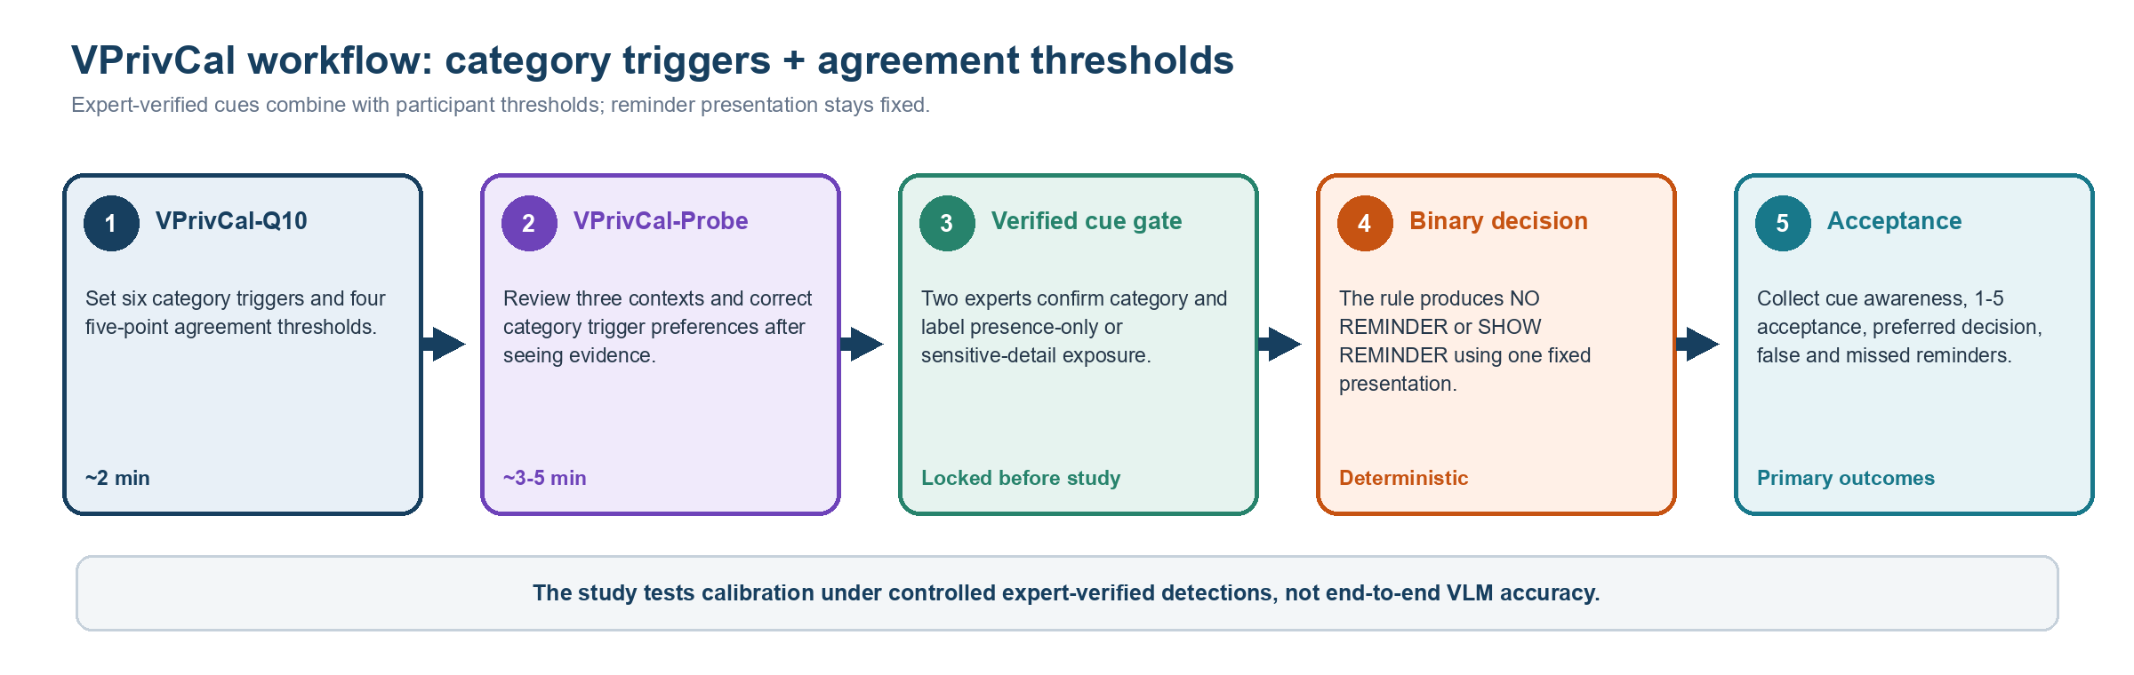
Review question | Rating / comment
Does the live workflow make clear that Q10 and Probe are two components of one method while the profile screen remains disabled? | 1 2 3 4 Comment: ______________________________
Is the 5-7 minute target credible when the required Hint walkthrough and category-complete review are included and timed separately? | 1 2 3 4 Comment: ______________________________
Is it clear that experts lock each cue as presence-only or sensitive-detail exposed before the participant policy runs? | 1 2 3 4 Comment: ______________________________

3. VPrivCal-Q10 candidate questions
Shared three-option category trigger scale for Q1-Q6
Do not show reminders for this category | Show reminders only when identifying or sensitive details are exposed | Show reminders whenever this verified category is present
Shared five-point agreement scale for Q7-Q10
Strongly disagree | Disagree | Neither agree nor disagree | Agree | Strongly agree
Distinct rule thresholds (minimum likelihood + severity score): 11 [never] | 9 | 7 | 5 | 2 [any verified cue]. The observed score ranges from 2 to 10. Q8 applies generally to every verified privacy threat; Q7, Q9, and Q10 apply when the cue is inferred, uncertain, or task-irrelevant.

Item | Category / policy dimension | Relevance | Clarity | Actionability | Predictive value | Decision
Q1 | Biometric data | 1 2 3 4 | 1 2 3 4 | 1 2 3 4 | 1 2 3 4 | Keep / Revise / Remove
Q2 | Children images | 1 2 3 4 | 1 2 3 4 | 1 2 3 4 | 1 2 3 4 | Keep / Revise / Remove
Q3 | Personally identifiable information (PII) | 1 2 3 4 | 1 2 3 4 | 1 2 3 4 | 1 2 3 4 | Keep / Revise / Remove
Q4 | Legal sensitivity information | 1 2 3 4 | 1 2 3 4 | 1 2 3 4 | 1 2 3 4 | Keep / Revise / Remove
Q5 | Personal life | 1 2 3 4 | 1 2 3 4 | 1 2 3 4 | 1 2 3 4 | Keep / Revise / Remove
Q6 | Background individuals | 1 2 3 4 | 1 2 3 4 | 1 2 3 4 | 1 2 3 4 | Keep / Revise / Remove
Q7 | Inferred privacy risks | 1 2 3 4 | 1 2 3 4 | 1 2 3 4 | 1 2 3 4 | Keep / Revise / Remove
Q8 | General reminder sensitivity | 1 2 3 4 | 1 2 3 4 | 1 2 3 4 | 1 2 3 4 | Keep / Revise / Remove
Q9 | Uncertain detections | 1 2 3 4 | 1 2 3 4 | 1 2 3 4 | 1 2 3 4 | Keep / Revise / Remove
Q10 | Task-irrelevant sensitive information | 1 2 3 4 | 1 2 3 4 | 1 2 3 4 | 1 2 3 4 | Keep / Revise / Remove

4. Item-specific prompts
Q1. Biometric data
Faces, fingerprints, and other distinctive body features that may identify a person.
Main concern / suggested wording: ______________________________________________________________
Q2. Children images
Children, school events, playgrounds, and child-related activities.
Main concern / suggested wording: ______________________________________________________________
Q3. Personally identifiable information (PII)
Financial or medical data; names, passports, email addresses, phone numbers, GPS, license plates, and other identifiers.
Main concern / suggested wording: ______________________________________________________________
Q4. Legal sensitivity information
Nudity or explicit imagery; violent or unlawful acts; criminal acts; weapons or other high-risk items.
Main concern / suggested wording: ______________________________________________________________
Q5. Personal life
Home interiors, personal items, location context, landmarks, routines, relationships, and activities.
Main concern / suggested wording: ______________________________________________________________
Q6. Background individuals
Passersby, bystanders, coworkers, patients, patrons, and other people incidentally captured.
Main concern / suggested wording: ______________________________________________________________
Q7. Inferred privacy risks
How much do you agree with the following statement?
"The assistant should show a privacy reminder when a visual cue supports a sensitive inference."
Main concern / suggested wording: ______________________________________________________________
Q8. General reminder sensitivity
How much do you agree with the following statement?
"In general, the assistant should show detected privacy threats to the user."
Main concern / suggested wording: ______________________________________________________________
Q9. Uncertain detections
How much do you agree with the following statement?
"The assistant should show a privacy reminder when it is uncertain whether a detected visual cue is privacy-sensitive."
Main concern / suggested wording: ______________________________________________________________
Q10. Task-irrelevant sensitive information
How much do you agree with the following statement?
"The assistant should show a privacy reminder when privacy-sensitive content is visible but not needed for the current task."
Main concern / suggested wording: ______________________________________________________________

5. VPrivCal-Probe stimuli
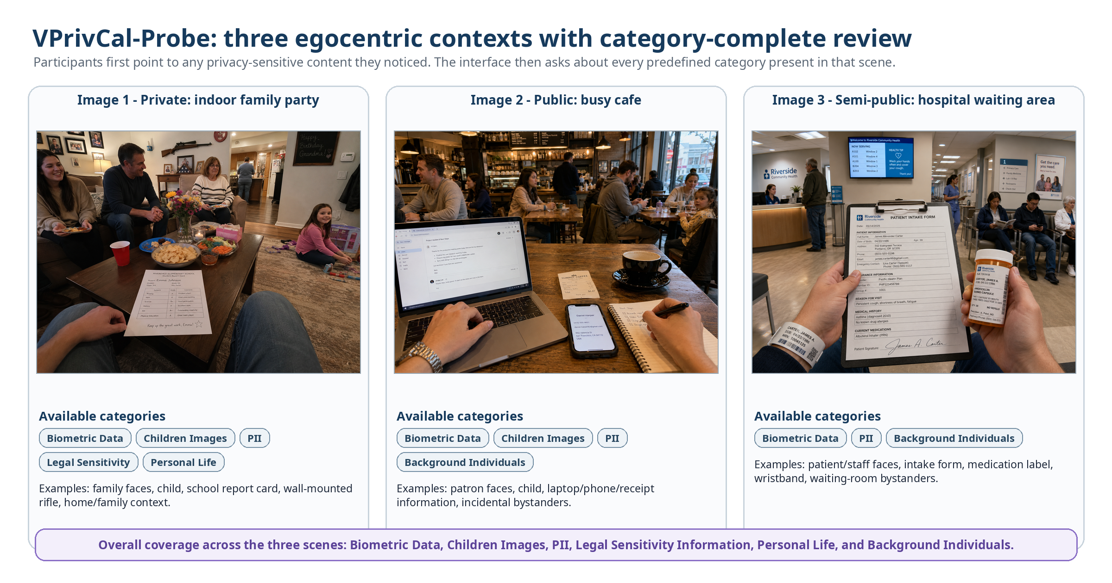
Two questions per internal category-scene pair
A. Before the highlight: already aware / noticed but did not consider privacy / did not notice or realize VLM capability / not a concern.
B. Preferred trigger: never remind / remind only for identifying or sensitive-detail exposure / remind whenever the verified category is present.
Category identities remain hidden; participants see neutral linked-content labels.
The stimuli span private, public, and semi-public contexts. Coverage remains scene-level and internally category-complete across all six high-level categories. Phase A is unprompted pointing; Phase B uses neutral linked-content labels because participant-facing category identities are hidden.

Criterion | Scene 1 | Scene 2 | Scene 3 | Comment
Context is realistic and distinct | 1 2 3 4 | 1 2 3 4 | 1 2 3 4 | ________________
Internal category coverage is complete for the scene | 1 2 3 4 | 1 2 3 4 | 1 2 3 4 | ________________
The optional evidence highlight is correctly localized and understandable | 1 2 3 4 | 1 2 3 4 | 1 2 3 4 | ________________
The scene includes both obvious and subtle privacy content | 1 2 3 4 | 1 2 3 4 | 1 2 3 4 | ________________
Point-first marking and neutral linked-content review are usable | 1 2 3 4 | 1 2 3 4 | 1 2 3 4 | ________________
Cultural and ethical risk is acceptable | 1 2 3 4 | 1 2 3 4 | 1 2 3 4 | ________________
Implemented sequence: require the five-step Hint before the first scene (practice data are not saved; Hint time is separate). Phase A shows a clean image: participants place/delete points or confirm none; category/detection matching is internal, unmatched points are retained, and only ambiguous overlaps trigger a neutral chooser. Phase B reviews every present internal category sequentially with neutral linked-content labels, an optional Show/Hide highlight, awareness status, and three-option reminder-trigger preference. Category identities remain hidden.

6. Probe-level review
Review question | Rating | Comment
Does the required five-step Hint teach point, delete, phase transition, response layout, and next-item navigation without contaminating real answers? | 1 2 3 4 | ________________________
Is it clear that Hint data are not saved and Hint time is excluded from Probe completion time? | 1 2 3 4 | ________________________
Does Phase A preserve an interpretable unprompted signal when categories and detections remain hidden and unmatched points are retained? | 1 2 3 4 | ________________________
Are neutral linked-content labels plus the Show/Hide highlight sufficient to identify the review target without category names? | 1 2 3 4 | ________________________
Are the awareness-status item, three-option category trigger, and five-point cross-cutting agreement items distinct, understandable, and sufficiently brief? | 1 2 3 4 | ________________________
Are pointer/delete, overlap chooser, move/zoom/pan/reset, keyboard controls, and list fallback sufficiently usable and accessible? | 1 2 3 4 | ________________________

7. Held-out evaluation review
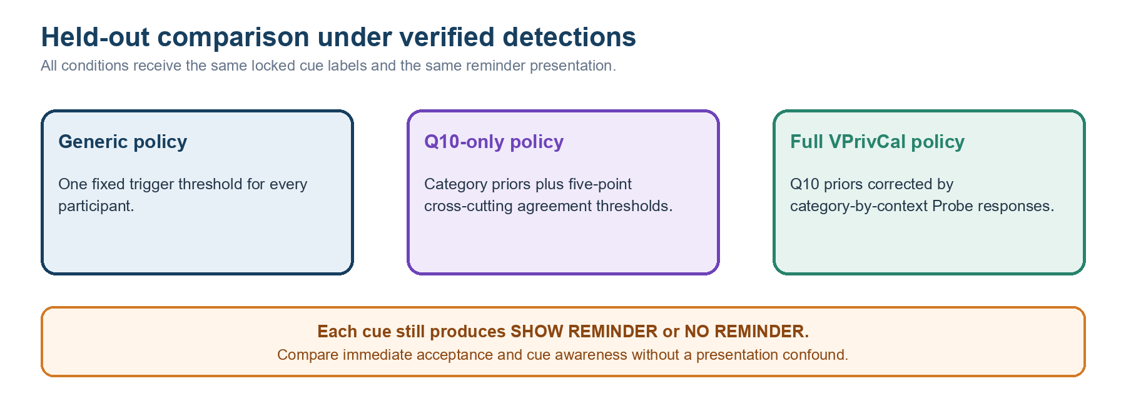
Metric / design decision | Expert judgment
Primary outcome: immediate acceptance rating (1-5) after each standardized reminder decision | Strong / Revise / Reject
Cue-awareness difference between generic and VPrivCal policies | Strong / Revise / Reject
Binary decision alignment, false-reminder rate, and missed-reminder rate | Strong / Revise / Reject
Two-expert verification of category and exposure level before study inclusion | Strong / Revise / Reject
Balance presence-only and sensitive-detail-exposed held-out cues where feasible | Strong / Revise / Reject
Treat simulations as software checks and short-video outcomes as immediate only; prespecify whether Q8 and Q10 values predict acceptance before considering later Q10 removal. | Strong / Revise / Reject

7.1 Exposure-label codebook review
Experts first confirm category membership. Then ask whether the visible cue identifies or links a person, or exposes a private fact about a person or household. If yes, label SENSITIVE_DETAIL_EXPOSED; otherwise label PRESENCE_ONLY. Disagreements are adjudicated or excluded before the cue JSON is locked.
Category | PRESENCE_ONLY anchor | SENSITIVE_DETAIL_EXPOSED anchor
Biometric data | Distant, occluded, or otherwise non-recognizable person/body feature. | A clear face or distinctive body feature that supports recognition or re-identification.
Children images | A child is present without a recognizable identity or linkable school/location detail. | A recognizable child, readable name, school affiliation, home link, or other identity/location detail.
PII | A document, screen, badge, plate, or device is present but identifying content is unreadable. | A readable name, address, account/contact number, email, plate, patient ID, or comparable identifier.
Legal sensitivity | A potentially sensitive object or setting is present without person-specific sensitive content. | Explicit content, a visible unlawful/high-risk act, or person-linked legal/safety information.
Personal life | A generic home, routine, relationship, or personal object is visible without a linkable private fact. | An intimate activity, precise location, relationship/routine, or household detail is exposed and linkable.
Background individuals | An incidental person is distant or non-recognizable. | A bystander is recognizable or linked to a readable name, workplace, health context, or other private detail.
Reviewer judgment: Can two independent experts apply these anchors consistently? □ Strong □ Revise □ Reject Comment: ____________________________________________

8. Final decision
VPrivCal-Q10: □ Proceed □ Minor revision □ Major revision □ Replace
VPrivCal-Probe interface (including Hint): □ Proceed □ Minor revision □ Major revision □ Replace
Workflow, expert verification, and immediate acceptance evaluation: □ Proceed □ Minor revision □ Major revision □ Replace
Simulated policy-output pre-verification: □ Proceed □ Minor revision □ Major revision □ Defer
Overall readiness for cognitive interviews: □ Yes □ Yes after revision □ No
Three highest-priority changes:
1. __________________________________________________________________________________
2. __________________________________________________________________________________
3. __________________________________________________________________________________
Alternative idea or missing test: ______________________________________________________________________

